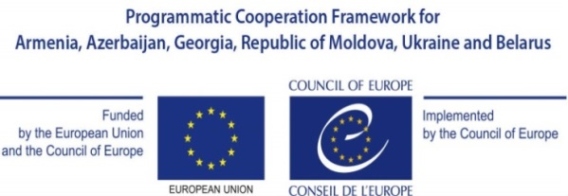
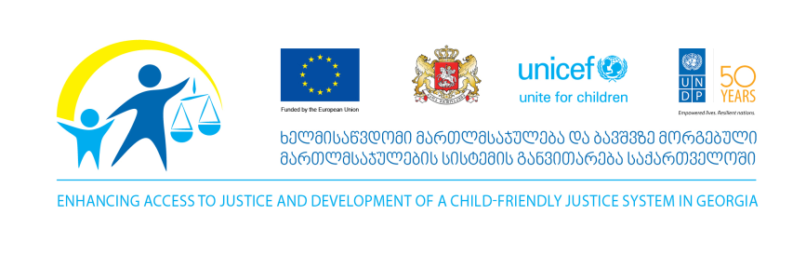

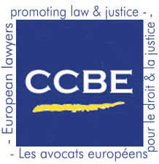
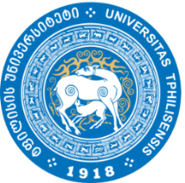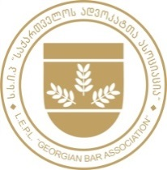

BAR ASSOCIATIONS WORKING TOWARDS

AN INDEPENDENT, QUALIFIED AND ETHICAL EXERCISE

OF THE PROFESSION OF LAWYER

20-21 June 2016

Venue: Tbilisi State University
Address: Chavchavadze Ave 1
Iv Javakhishvili room

Day 1, 20 June 2016
09:30 – 10:00 | Registration and Welcome coffee
10:00 – 11:00 | Opening Remarks
Zaza Khatiashvili, President of the Georgian Bar Association
Giorgi Margvelashvili, President of Georgia
Cristian Urse, Head of the Council of Europe Office in Georgia
Stephen Stork, European Union Delegation to Georgia
Shombi Sharp, Deputy Resident Representative, United Nations Development Programme
Ruthven Gemmell WS, Council of Bars and Law Societies of Europe, First Vice- President
Irakli Burduli, Tbilisi State University Law Faculty, Dean

11:00 – 13:00 | Opening Session  Moderator: David Asatiani, International Secretary of the Georgian Bar Association
11:00 | The Role of Bar Associations in professional deontology  Lucy Dupong, Chair of the Deontology Committee (2009-2014), Council of Bars and Law Societies of Europe
11:30 | The Role of Bar Associations in lawyers training  Pier Giovanni Traversa, Chair of the Training Committee, Council of Bars and Law Societies of Europe
12:00 | The Role of Bar Associations in defending and promoting lawyers rights  Maria Ślązak, Vice President of the Polish Bar of Attorneys, President of the Council of Bars and Law Societies of Europe in 2015
12:30  12:50 | Questions & Answers  Group Photo
13:00 - 14:00 | Lunch
PARALLEL WORKING SESSIONS

14:00 - 15:00 | Session on Bar Associations role in lawyers training  Moderator: Pier Giovanni Traversa, Council of Bars and Law Societies of Europe, Chair of the Training Committee  Co-rapporteur: Irakli Kandashvili, Georgian Bar Association Board Member  Iv. Javakhishvili Room
14:00 - 15:00 | Session on Bar Associations role in professional deontology  Moderator: Lucy Dupong, Chair of the Deontology Committee (2009-2014), Council of Bars and Law Societies of Europe  Co-rapporteur: Tsitsino Tskhvediani, Chairwoman of the Georgian Bar Association Ethics Commission  Room 06
15:00 - 15:30 | Coffee Break
15:30 - 17:00 | Continuation of Working Sessions
17:00 - 17:15 | Coffee Break
17:15 - 18:00  18:15 | Plenary:  presentations from working sessions by moderators and co-rapporteurs  Iv. Javakhishvili Room  Departure for Dinner (hosted by the Georgian Bar Association, transportation provided)
Day 2, 21 June 2016
09:30 - 10:00 | Welcome Coffee
10:00 - 12:00 | Session on Bar Associations role in defending and promoting lawyers rights  Moderator: Maria Ślązak, Vice President of the Polish Bar of Attorneys, President of the Council of Bars and Law Societies of Europe in 2015  Co-rapporteur: Zaza Khatiashvili, President of the Georgian Bar Association  Iv. Javakhishvili Room
12:00 - 12:15 | Coffee break
12:15 - 13:00 | Plenary: presentation from working session  Concluding Remarks
13:00 - 14:00 | Reception

16:00-19:00 Excursion in the City of Mtskheta (transportation provided)
19:00 Dinner (Hosted by the Georgian Bar Association)

